Things that don’t work well

* Index (NDVI, ENVI, EVI, etc.) → ground truthing values
  + NDVI & Chlorophyll: 0.1416

NDVI & NDVI: 0.0953

NDVI & Height: 0.1935

NDVI & Leaf Count: -0.0823

NDVI & WP: 0.3681

* + 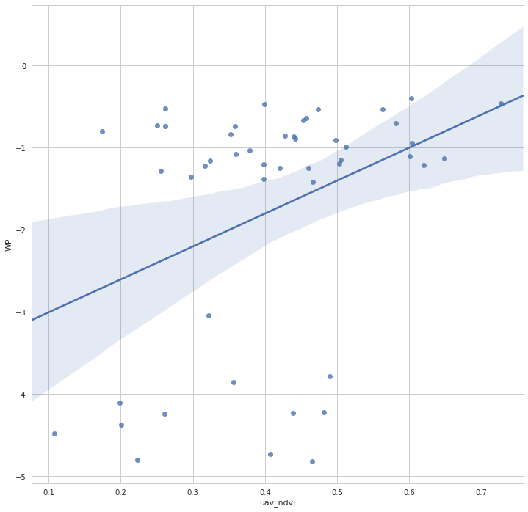Low variance in lettuce
    - Reduce initial water period?

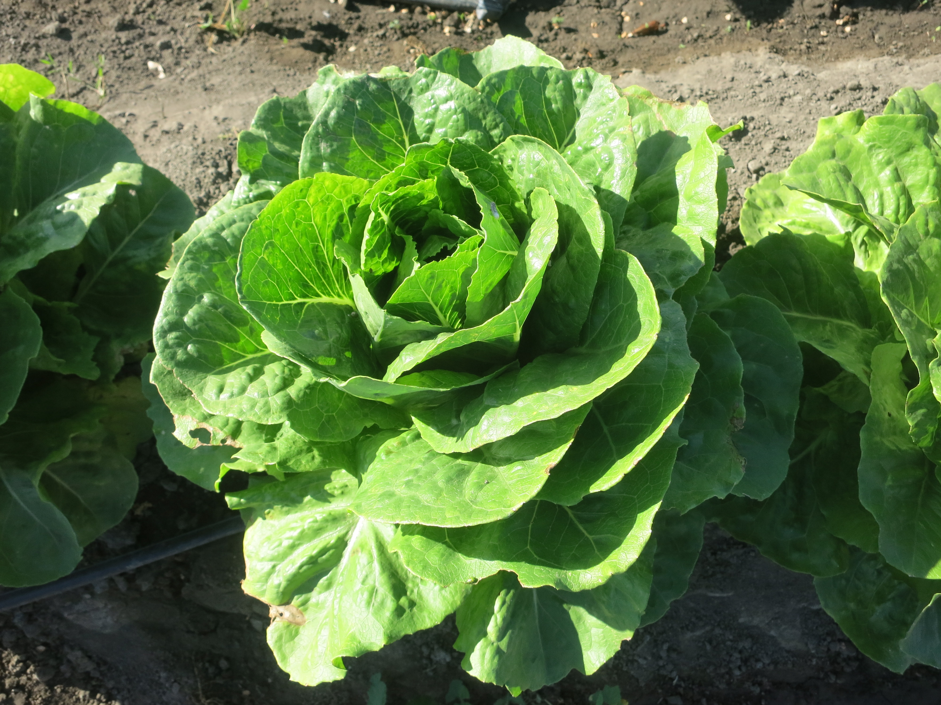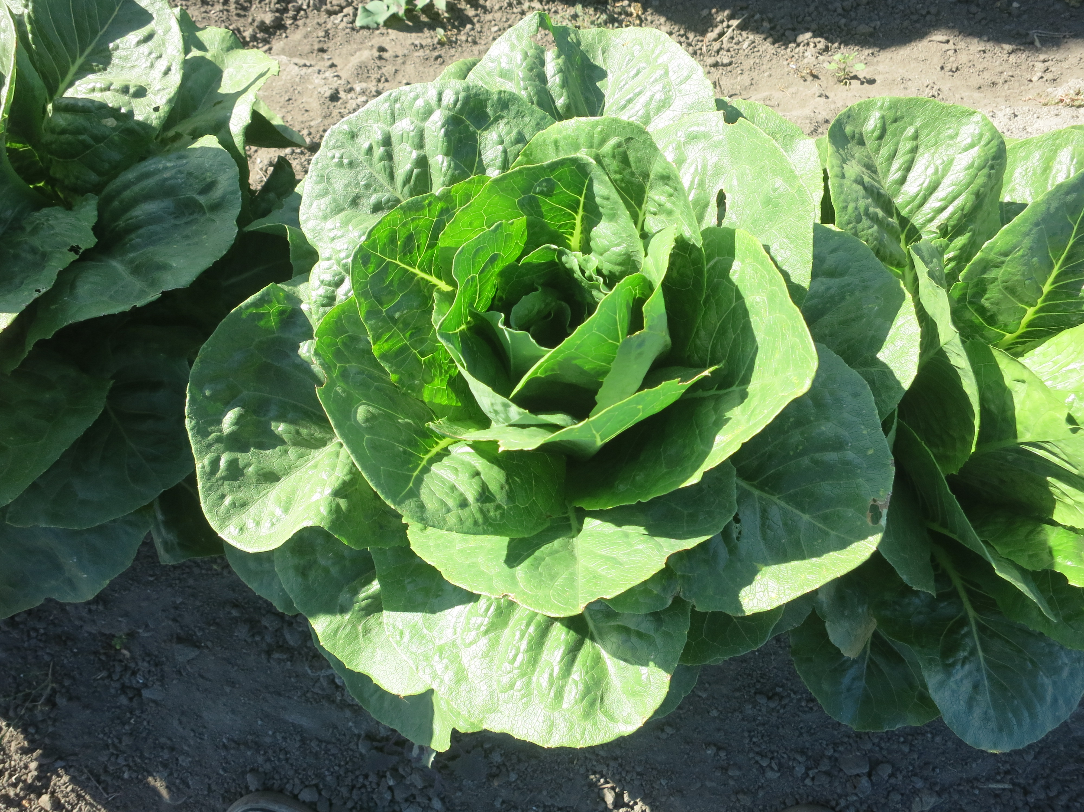

* Predicting nitrogen or chlorophyll values
  + Empirically, this didn’t work well
  + Theoretically, according to Joseph, this shouldn’t work very well

Things that kind of work

* RGB → Irrigation class (4 classes) 60% accuracy
* 5 Channel → Irrigation class (4 classes) 58% accuracy
* Lettuce detection (could be better)

Things that do work

* 5 Channel → water potential (2 class) 86% accuracy (on incomplete dataset)
* RGB image → NDVI image
  + FC-DenseNet Model
  + 4.89 MAE per pixel

